

**Final Project - Analysis Software Analysis and Design**

**Part A: Analysis and requirements gathering**

**Weight: 12.5% Marks: /50**

**Student Name (Student ID):** Grace Bruketa (000943039), Rodrigo Alves Rangel (000931691), Ryan Howie (000279872)

**Date:** August 02nd of 2024

**USE CASE DIAGRAM**

The following use cases are meant to be performed through a GUI.

* Manage Inventory: the system will store data related to each equipment registered in the rental store.
  + Add Equipment: new equipment will be added and tracked in the system with a unique identifier and descriptive data.
  + Create Equipment Category: categories will be created to be associated with equipment for improved management.
  + Remove Equipment: equipment that are registered in the system can be removed from the system and put to sale.
* Manage customers: the system will store information regarding each customer that intends to reserve an equipment.
  + Register new customer: a customer can be registered in the system.
  + Update Customer Information: an existing customer registration may have its information reassigned and updated in the database.
* Generate Reports: the system will gather data from the database to create reports.
  + Sales by date: a report that displays the data related to each rental executed at a given date.
  + Sales by customer: a report that displays historic, current, and foreseeing rental data related to each rental executed by a given customer.
  + List items by category: a report that displays the equipment registered under a given category.
  + Other *order by* reports: custom reports that will provide consolidated overviews from sales and equipment ordered by a given argument.
* Create Equipment Rental: each equipment rental will be performed through a creation of a registration that will be stored in the system. This will be associated with a customer profile that is registered in the system, so as with the profile from the requested equipment.
  + View Equipment Availability: only equipment that are available to be rented will be considered in a reservation. Therefore, the user may check for the equipment availability when creating the rental.

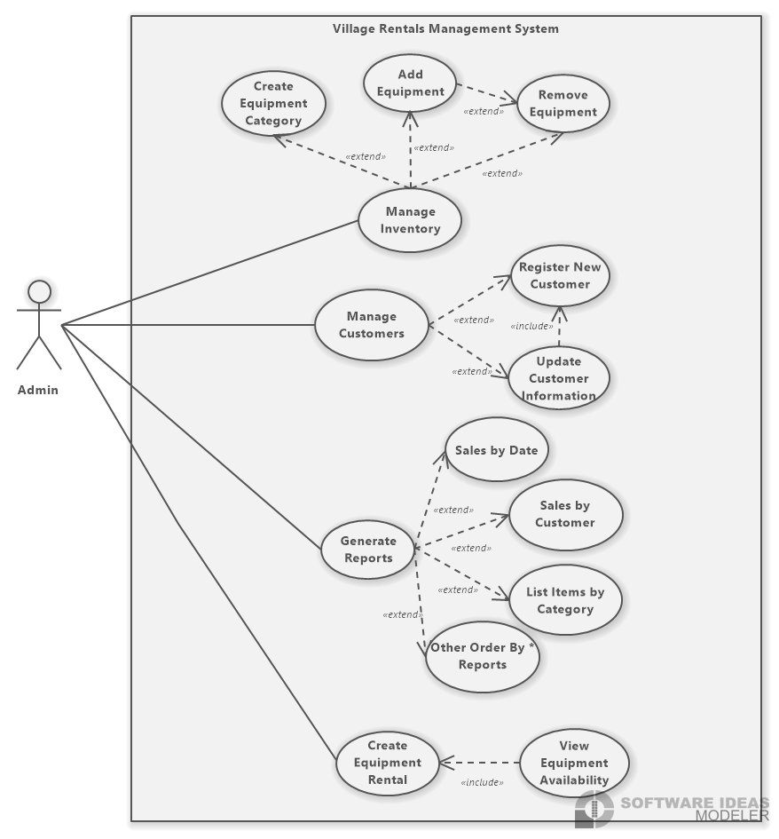

**ANALYSIS LEVEL CLASS DIAGRAM**

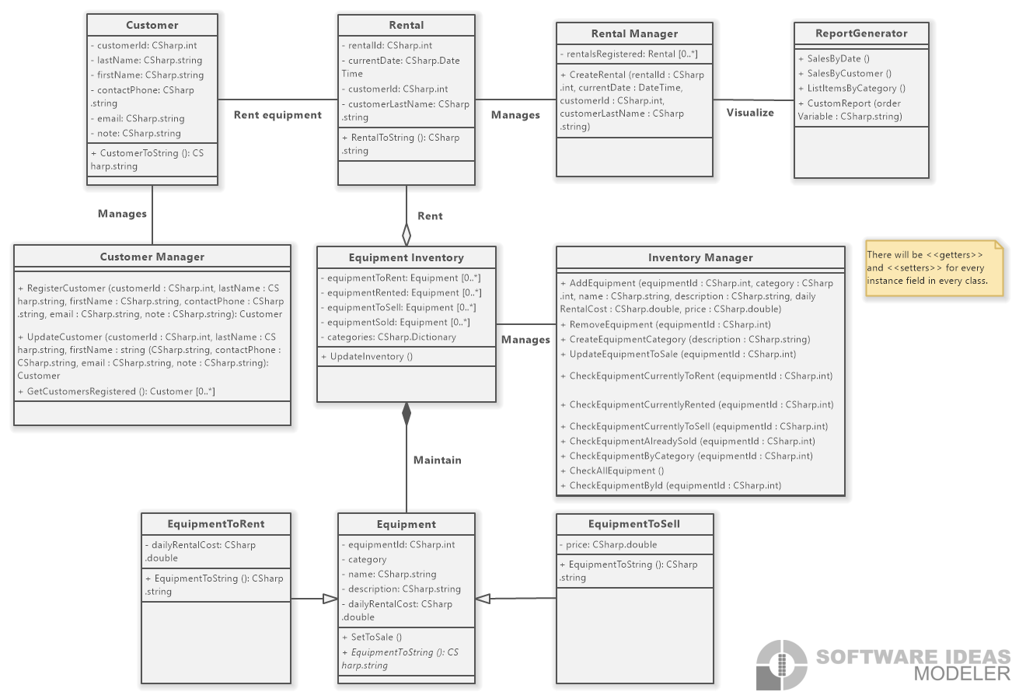

**CONCEPTUAL ENTITY RELATIONSHIP DIAGRAM (ERD)**

**ANALYSIS-LEVEL SEQUENCE DIAGRAM**

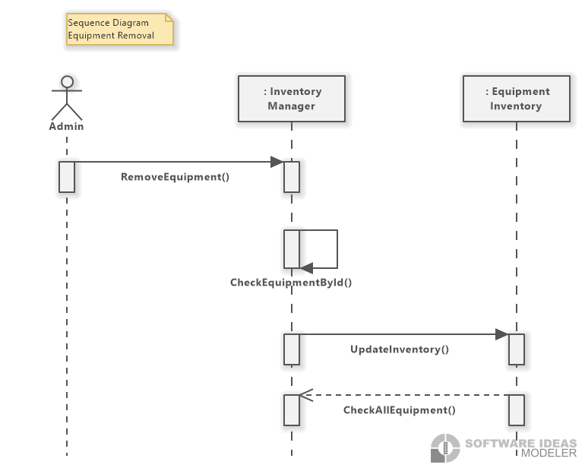

**ANALYSIS-LEVEL ACTIVITY DIAGRAM**

